**Screenshot of dashboard**

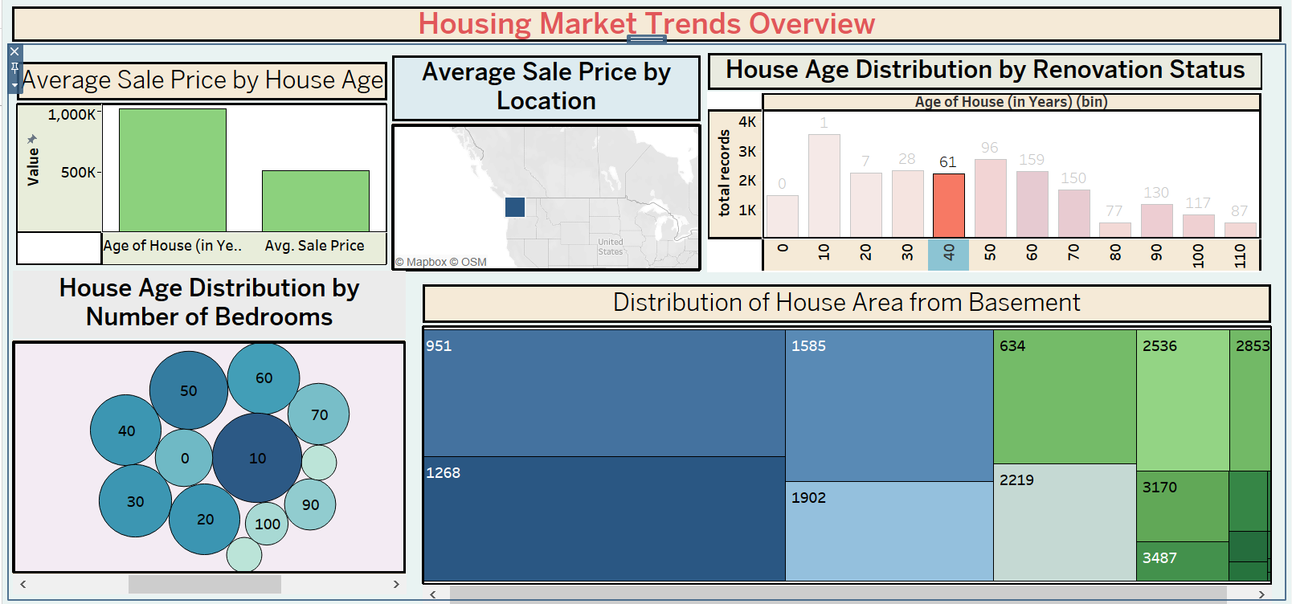

**Screenshots of story**

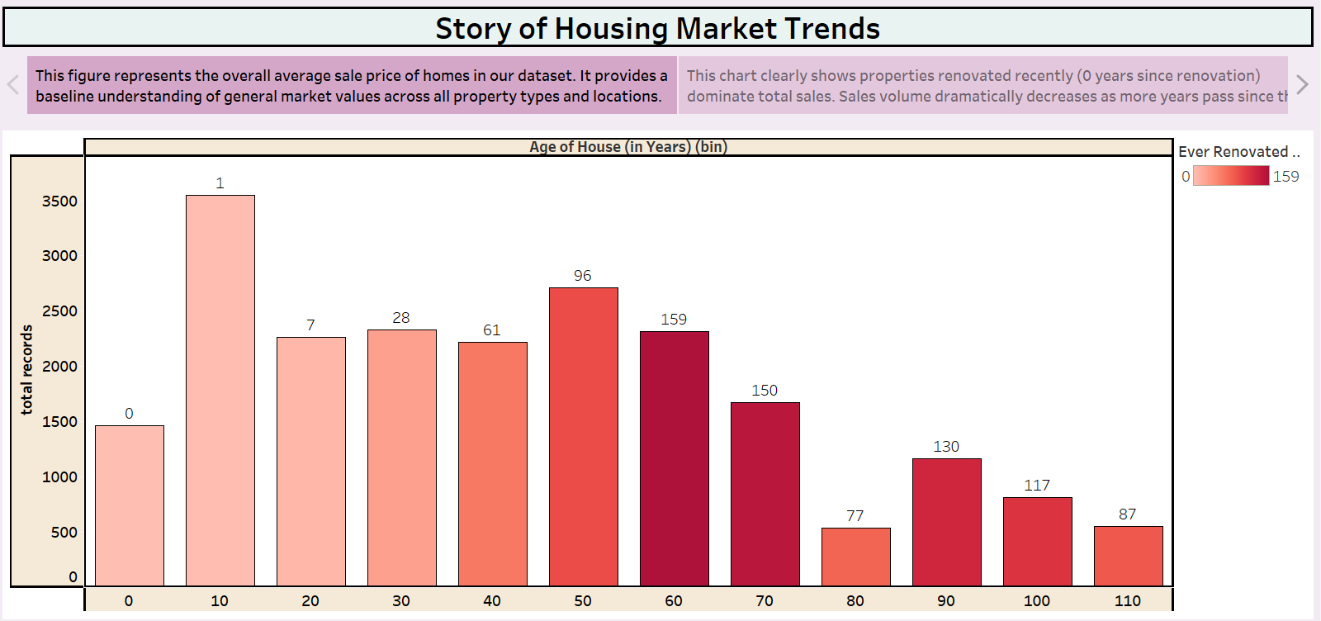

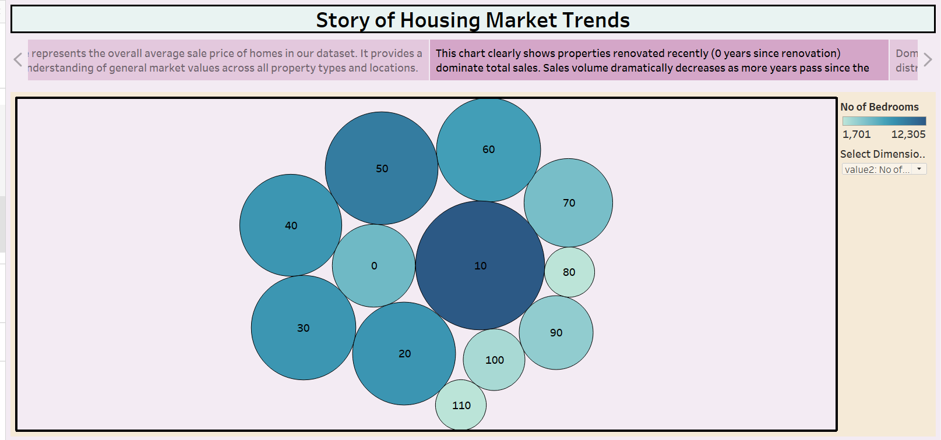

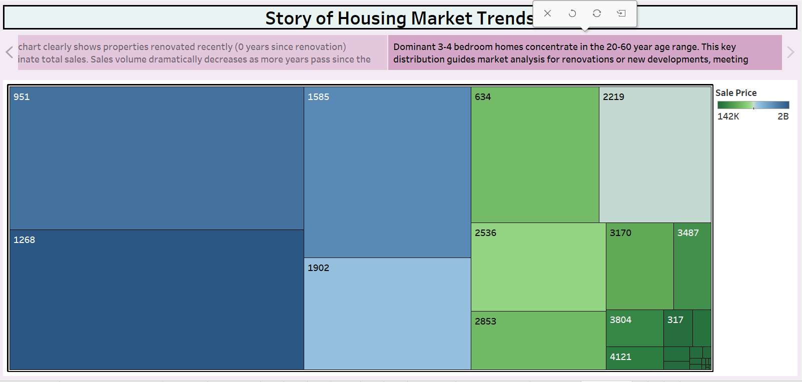

**Dashboard link**

<https://public.tableau.com/views/housingmarketdashboard/Dashboard1?:language=en-US&publish=yes&:sid=&:redirect=auth&:display_count=n&:origin=viz_share_link>

**story link**

<https://public.tableau.com/views/housingmarketstory/Story2?:language=en-US&publish=yes&:sid=&:redirect=auth&:display_count=n&:origin=viz_share_link>